
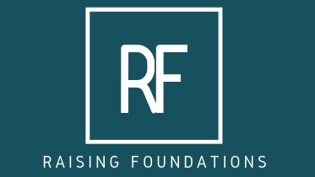

Charity Gift Aid Declaration

Boost your Donation by 25%, that’s 25p of Gift Aid for every £1 you donate

Gift Aid is reclaimed by the charity from the tax you pay in the current tax year. Your address is needed to identify you as a current UK taxpayer.

In order to Gift Aid your donation you must tick the box below:

I want to Gift Aid my donation of £ ____ and any donations I make in the future or have made in the past 4 years to:

Name of Charity: RAISING FOUNDATIONS

I am a UK taxpayer and understand that if I pay less Income Tax and/or Capital Gains Tax than the amount of Gift Aid claimed on all my donations in that tax year it is my responsibility to pay any difference.

My details:

Title(s) |  |  |  | First Name or Initial(s)

Surname

Full Home Address
Postcode |  |  |  |  |  | Date

Email (Optional) |  | Tel (Optional)

Please email this form to Info@raisingfoundations.org and notify us if you:
- Want to cancel this declaration
- Change your name or home address
- No longer pay sufficient tax on your income and/or capital gains

If you pay Income Tax at the higher or additional rate and want to receive the additional tax relief due to you, you must include all your Gift Aid donations on your Self-Assessment tax return or ask HM Revenue and Customs to adjust your tax code.

MAKE A DONATION

If you would like to support Raising Foundations you can make a donation via any of the following methods:

ONLINE VIA PAYPAL ON OUR WEBSITE
 | Online via Paypal on our website raisingfoundations.org using your debit or credit card. UK taxpayers will be given the option to select Gift-Aid during the process
OR
INTERNET BANKING
You can login to your Internet Banking Account to make a donation by electronic transfer or setup a regular donation by standing order using the account details below:
Our bank details are:
Account Name: Raising Foundations
Bank Name: CAF Bank
Account Number: 00029130
Sort Code: 40-52-40
Reference: Please quote your surname and initials

OR

TEXT
 | Text RAIS75 and a £5, £10 or £20 donation to 70070  Example: RAIS75 £10  This is a free service for UK subscribers and the only charge is the donation itself. 100% of your donation (including Gift Aid) will be sent to us

Please email info@raisingfoundations.org
to advise if you have made a payment or set up a standing order

